Ex. No:13 NETWORK FORENSICS USING PCAPXRAY TOOL
AIM:
To analyze a PCAP file using PcapXray and visualize network activity for basic
network forensic investigation.
ALGORITHM: For Installing PCAP and Analyzing:
1. Install PcapXray dependencies using: sudo pip3 install -r
requirements.txt
2. Launch the tool with: sudo python3 PcapXray.py
3. Open the web interface and upload the given PCAP file.
4. Click Analyze to process the packet data.
5. View the generated network topology and communication graph.
6. Examine hosts, protocols, and suspicious connections.
7. Save the generated report and diagrams for documentation.
Working entirely in Chrome without installing:
https://wiki.wireshark.org/SampleCaptures
What to do
1. Open the link above.
2. Find ipv4frags.pcap.
3. Download it to your Downloads folder.
4. Open your online PCAP analyzer.
5. Click Upload.
6. Select:
ipv4frags.pcap
7.Click Analyze.
Working entirely in Chrome without installing:
Yes. Let me show you exactly what to click and what to look for in A-Packets. You can do
this entirely in Chrome.
Step 1 — Open A-Packets
Open the official upload page:
A-Packets PCAP Upload

You should see “Choose a PCAP” / “Click or Drop to Select.” A-Packets currently accepts
.pcap, .pcapng, and .cap files, with a 25 MB free limit.

Step 2 — Get a sample PCAP
For your first experiment, use a sample PCAP, not your personal network traffic.
You can download ipv4frags.pcap from the Wireshark sample captures collection:
Wireshark Sample Captures
Save the file in your Downloads folder.
Step 3 — Upload the file
On A-Packets:
Click/Drop to Select
Then:
Downloads → ipv4frags.pcap → Open
You should see the filename appear on the page.
Then click:
Upload PCAP and Analyze
A-Packets says the analysis normally takes only a short time, depending on the capture.
Step 4 — Examine the results
After processing, you&#39;ll get a results page.
Summary:
This gives you an overview of the PCAP, such as:
• Number of packets
• Capture duration
• Traffic information
• Hosts involved
The A-Packets documentation describes a summary and traffic analysis view

OUTPUT:
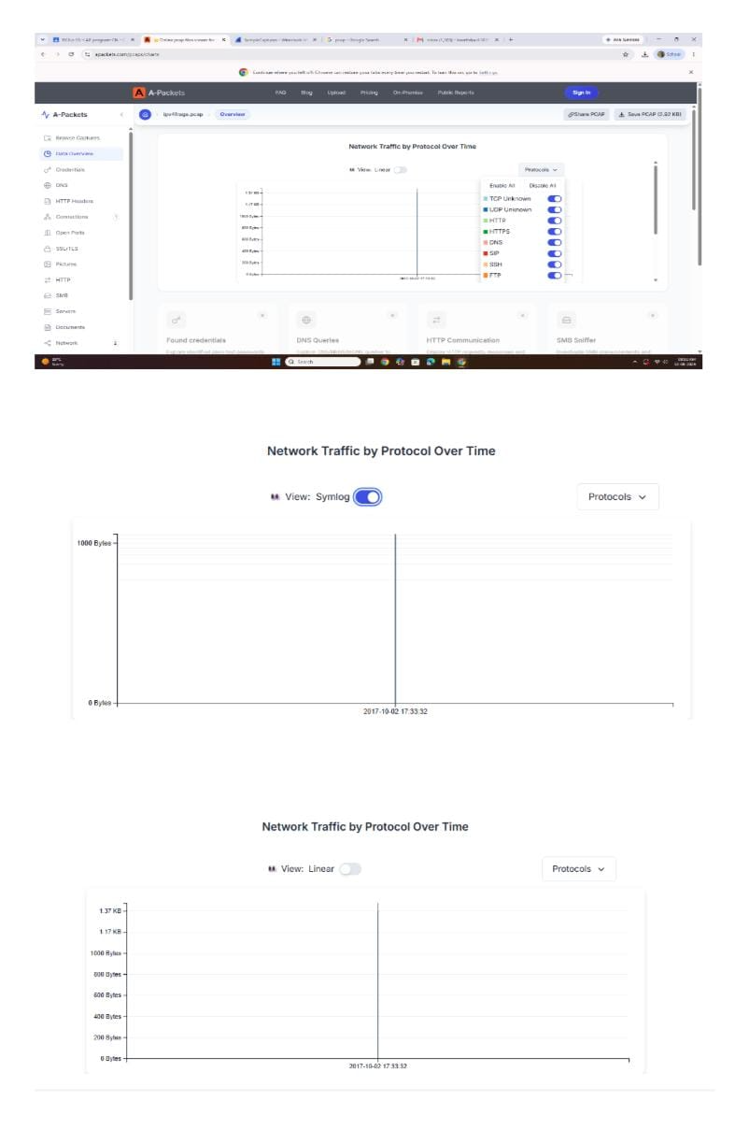
RESULT:
The PCAP file was successfully analyzed using PcapXray, and the network activities,
communicating hosts, and protocols were identified and visualized.

